Stock Space

Developer’s Manual

**Index**

* Activity Diagram – Mobile
* Sequence Diagram – Mobile
* State Diagram – Mobile
* Use Case Diagram – Mobile
* Activity Diagram – Inventory
* Sequence Diagram – Inventory
* State Diagram – Inventory
* Use Case Diagram – Inventory
* Activity Diagram – Sales Register
* Use Case – Sales Register
* Sequence Diagram – Repair
* Class Diagram
* ERD

**Activity Diagram- Mobile**

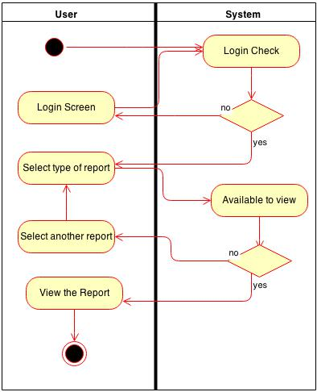

This diagram shows the activity flow when the user is accessing the system from a mobile app. When the user puts in the login details the system verifies them, if incorrect the user is taken back to login screen while if the details are correct the system asks for the type of report that the user wants to see. If the report is available for viewing it is displayed on screen while if the report is unavailable the user can see another report or sign out of the system.

**Sequence Diagram-Mobile**

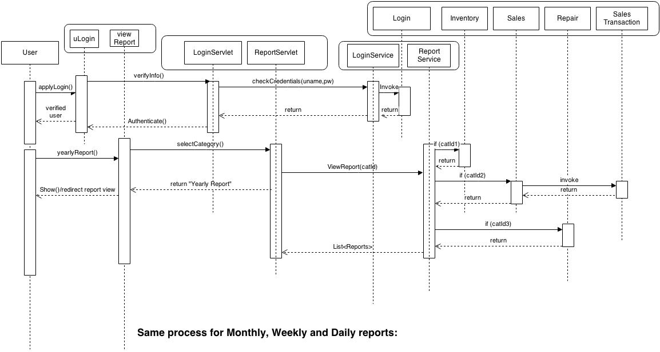

This diagram shows how the reports are displayed to user on a mobile app step by step. First of all when the user tries to login the Login Servlet sends to verify the credentials of the user to Login Service which if verified allows the Login Servlet to authenticate the user that way user enters the system.

When the user requests the system for a report, for instance a yearly report, the Report servlet sends the request to the Report Service. Report Service checks if the report is for Inventory, Sales, Sales Transactions or Repairs. Once verified the requested report is forwarded to the user by Report Service through Report Servlet.

**State Diagram - Mobile**

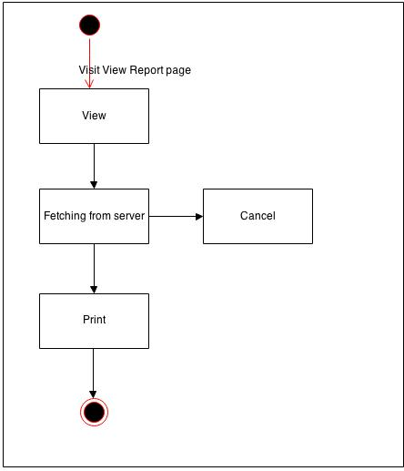

This diagram shows various states of the system while the user uses it for viewing various reports. Classified broadly the system has four main states. The first one is when the system is displaying the report requested by the user. The second one is when the system is pulling the requested reports from the server. If the desired reports are not available the system enters the cancel state. System is in printing state when the user wants a particular report to be printed.

**Use Case Diagram - Mobile**

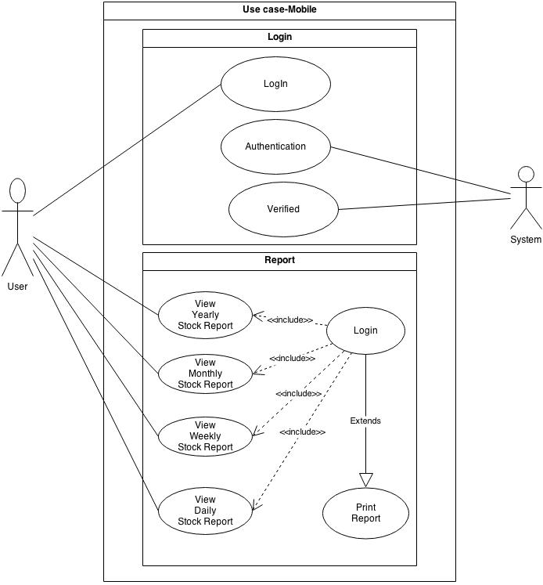

This is the Use Case diagram of the Mobile Application used to access the reports on a handheld device. The system has two different modules, Login and Reports. The Report module can only be accessed if the user is able to login successfully. The user can Login with his credentials and the system verifies and authenticates the user to enter the system. Once verified the system allows the user to view the yearly, monthly, weekly or daily reports based on requirement. The user can also print the report from the application.

**Activity Diagram – Inventory**

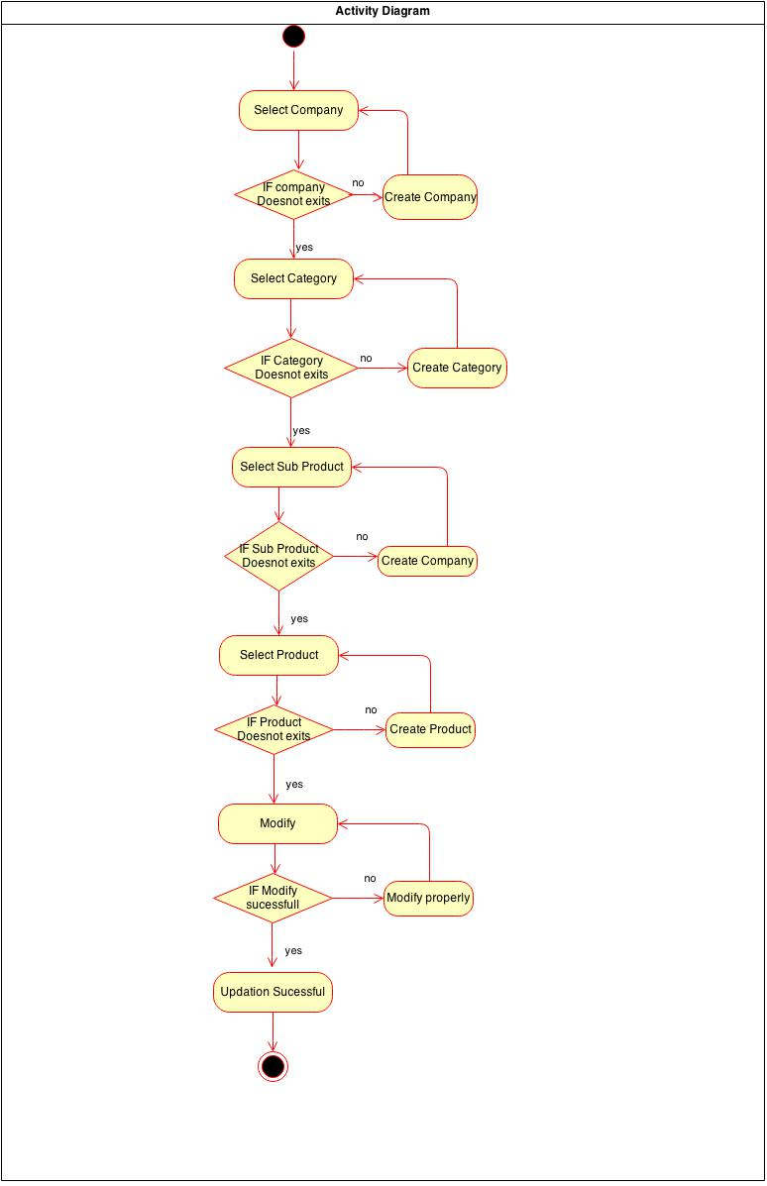

This is the Activity diagram for the Inventory Management module of the system. The user can select a particular product, update and modify its details by first selecting the company, category and sub product respectively. Similarly new products can be added to the inventory by creating a new company, category, product and sub product if any of these are non-existent in the system.

**Sequence Diagram – Inventory**

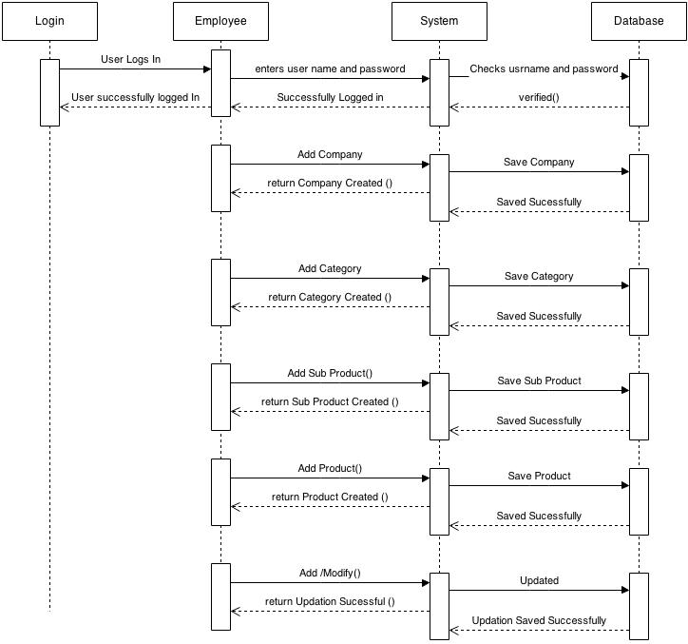

This diagram shows the sequence of steps which are followed to access a particular product or at add a new product in the system. For every stem the system acts as an intermediary between the user and database. The system fulfills user’s requests by fetching required data from the database. When the user enters its credentials the system verifies them by matching with the database. After that the same sequence is followed to add a new company, category, product and subproduct. If the user wants to modify existing records the system has to make changes in the database by following same steps.

**State Diagram – Inventory**

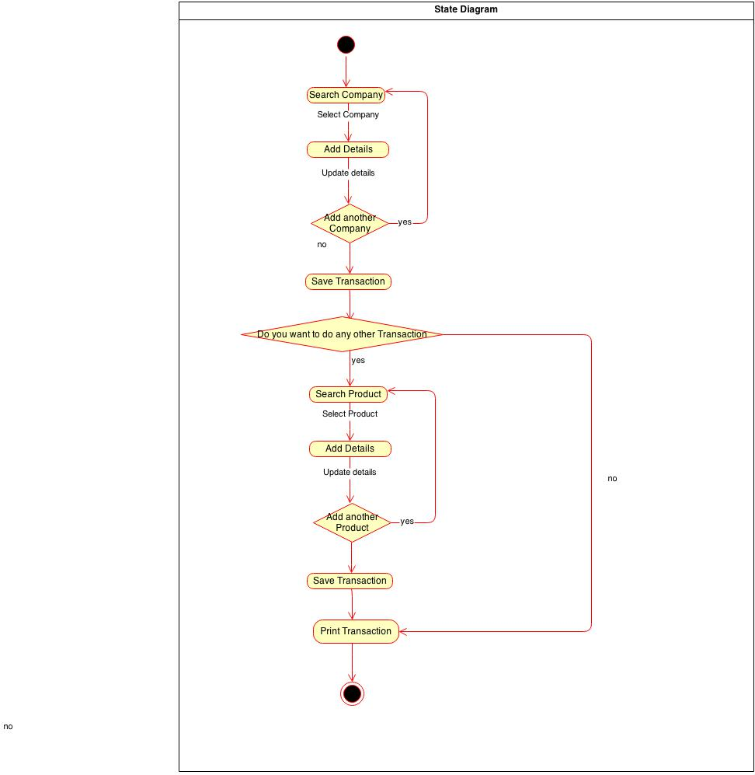

This is the state diagram for Inventory module. The user can search and modify and update details of existing companies and products in the system. Also new companies can be added in similar fashion. Every transaction made by the user is saved by the system. The user can take a printout of every transaction.

**Use Case – Inventory**

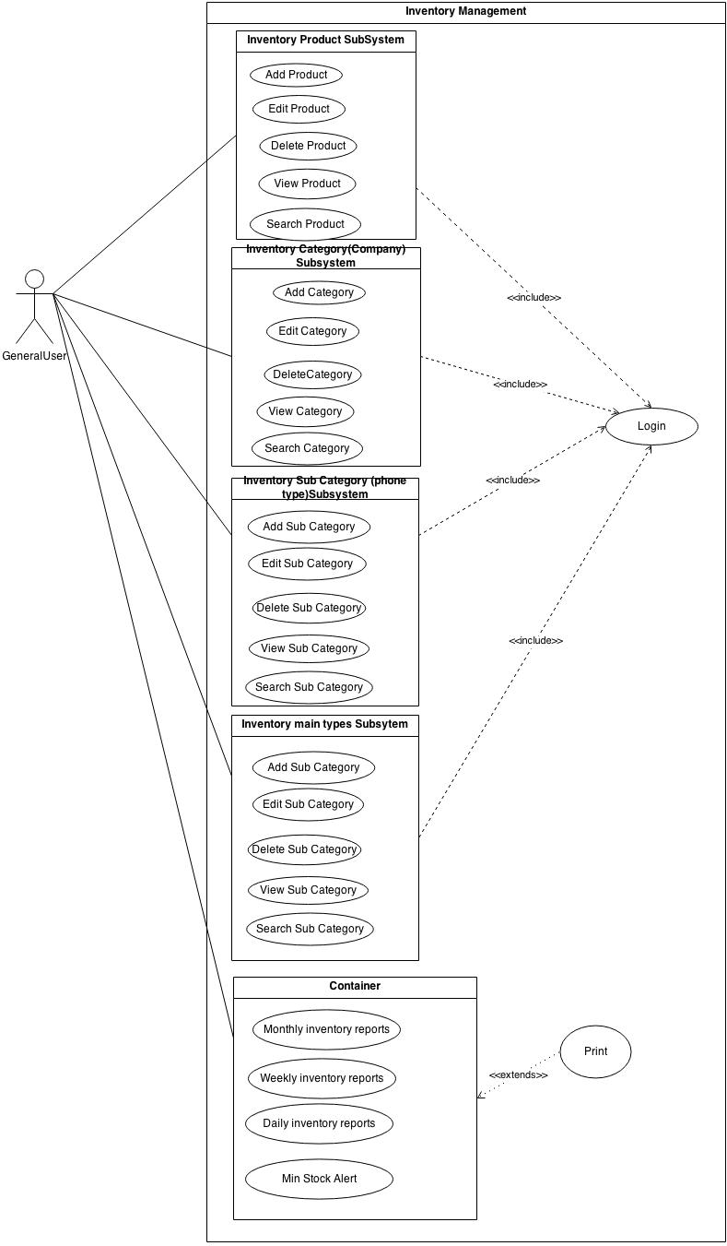

This is the use case diagram for the Inventory Management module. The whole module is divided into five sub systems, which are Product, Category, Sub Category, Sub Product and Reports. All these sub systems are available to user once he is able to login successfully. These sub systems allows the user to perform Add, Edit, Delete, View and Search functions based on their respective functionalities. The Report sub system allows the user to view and print various kinds of reports spanning different time frames.

**Activity Diagram – Sales Register**

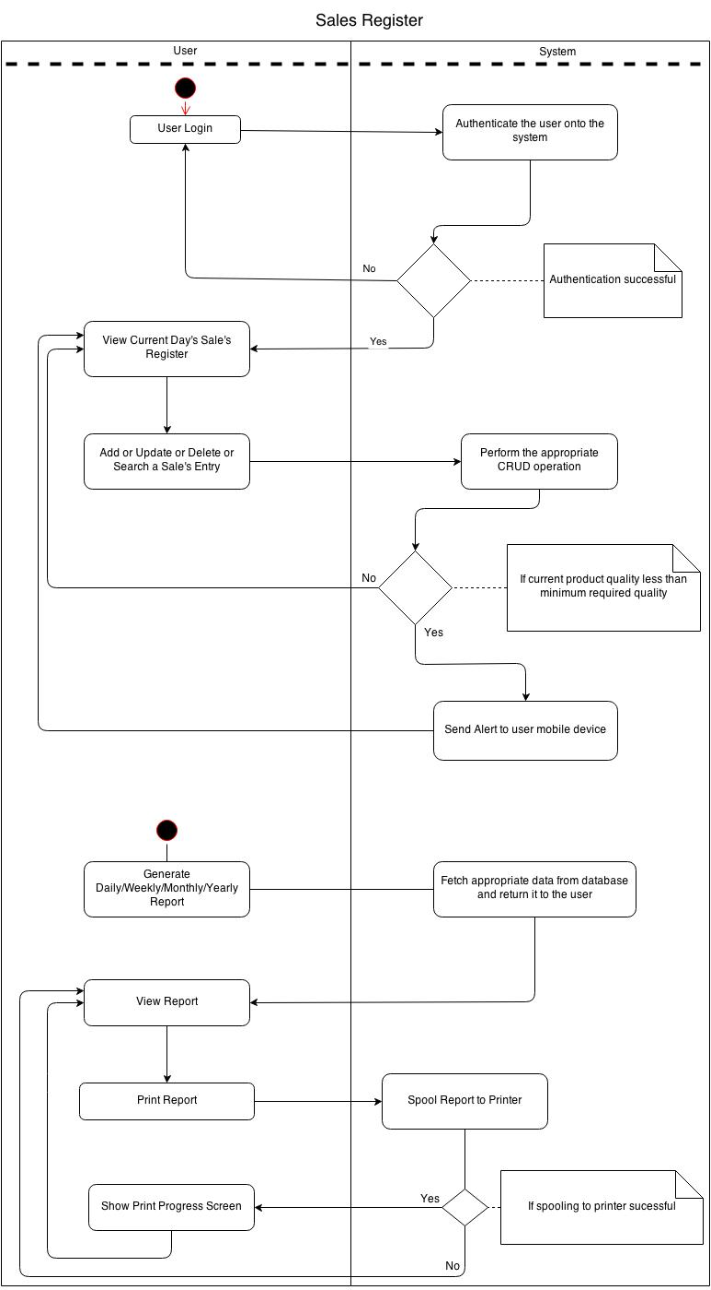

This diagram shows various user functions on the sales register of the system. Once user’s credentials are authenticated he can see current day’s sales and can perform various operations like adding, searching, updating and deleting a sales entry. If the system is successfully able to perform these operations an alert is sent to the user’s mobile device.

From the sales register the user can generate daily, weekly, monthly or yearly reports based on sales. For these reports the system pulls required data from the database and presents in the form of a report. The user can take a printout of the report.

**Use Case – Sales Register**

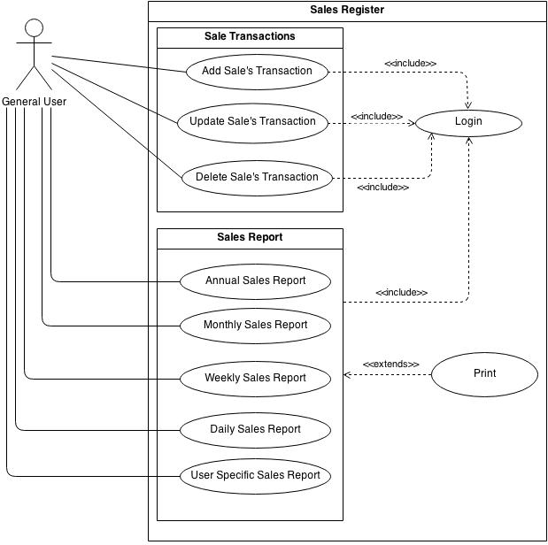

The Sales Register module comprises of two sub systems. One of them deals with routine sales transactions while the other one generates various sales reports based on different time spans. Both of these modules can be accessed by the user if he is able to login successfully. After logging in user can perform different sales transactions like add, update and delete a sale while he can also generate and print various reports as per requirement.

**Sequence Diagram – Repair**

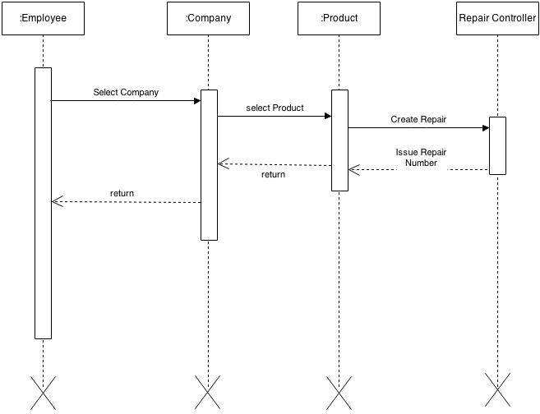

This diagram shows the sequence of steps which are followed while dealing with the repairs module of the system. After logging successfully into the system the user can select the company and product, according to the device which the customer has given for repairing. Once the attributes are punched in correctly a repair is created in the system and a unique repair id is assigned to it.

**Class Diagram**

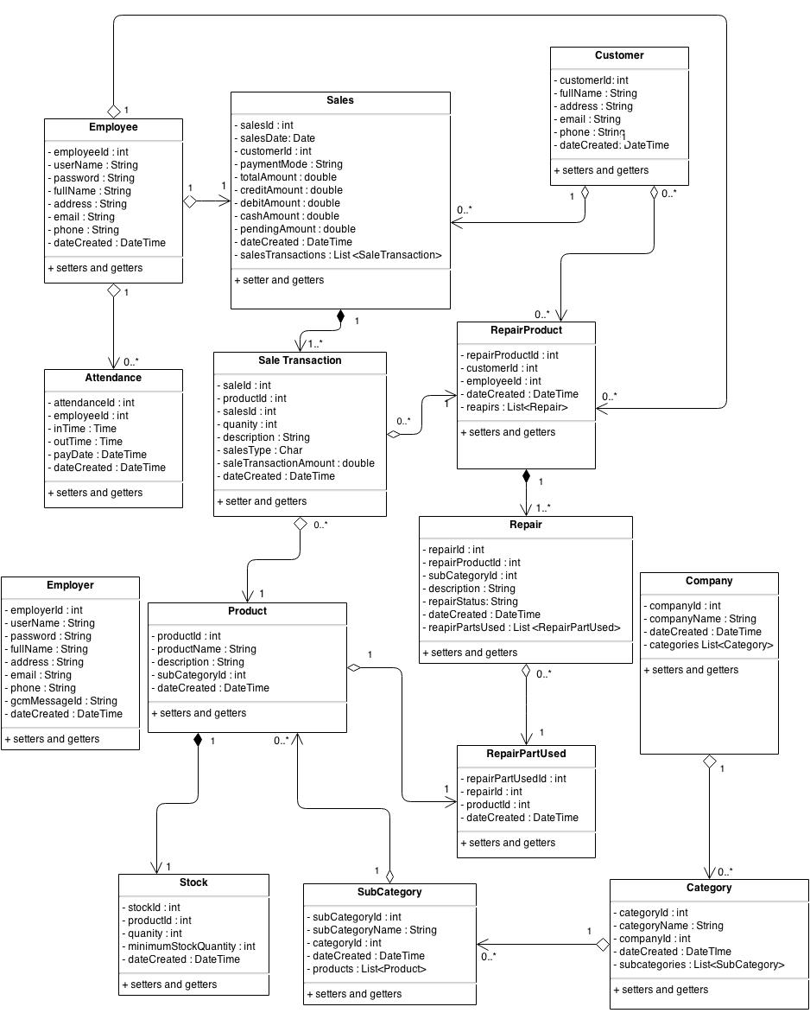

This diagram shows 14 different classes in the system and their interrelationship. The various classes used are Employee, Sales, Customer, Product, Repair etc. All these classes have their respective fields to capture the data originating for each entity. As from the diagram it is very much clear that these classes are related to each other. For e.g. category can have zero to many companies, an employee can have one attendance likewise.

**ERD**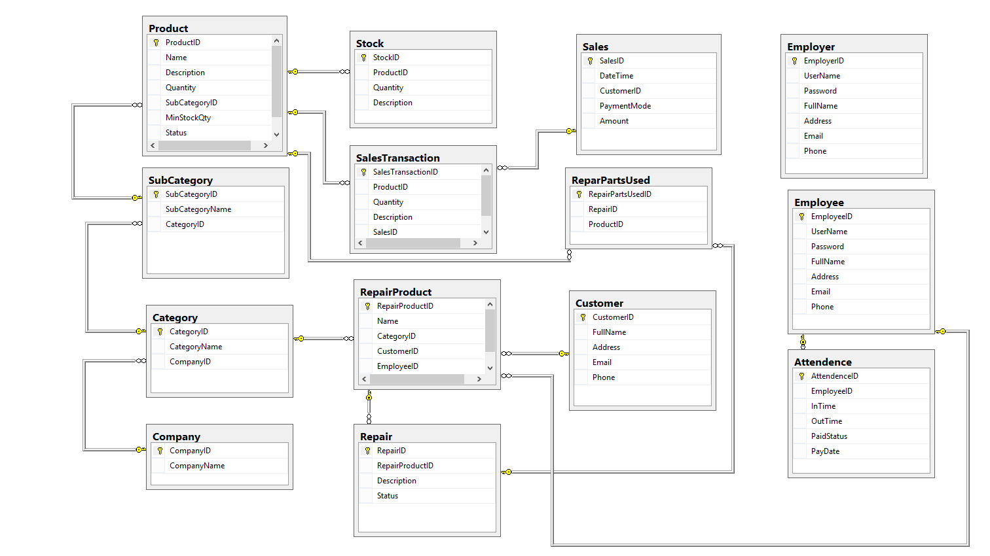

This diagram states that consenting to the class diagram and there are 14 different tables in the database like Product, Stock, and Sales etc. Each table is related to one or another and have a certain relationship. The yellow key signifies that the primary key in that particular table is foreign key in the table on the other end for e.g. Attendance has the foreign key from employee. Examples of the relationship can be one between Product and Sub Category to identify that a particular product belongs to which category.